Open SSMS.
Click on Tools on the menu bar
Click on External Tolls…

A Response window opens. Click on Add, then fill out as shown below.

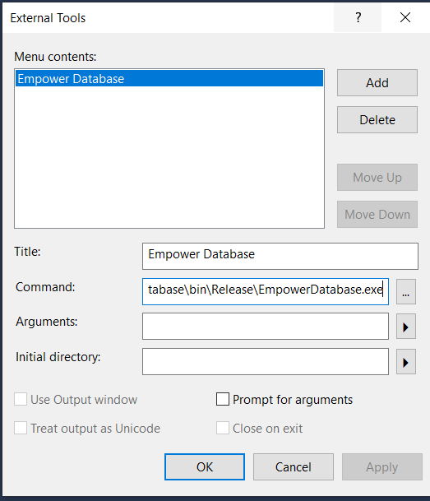

The full command line is:

C:\TFS\rmurray\EmpowerNet\Main\Windows\EmpowerDatabase\bin\Release\EmpowerDatabase.exe

Click Apply. Click OK.

